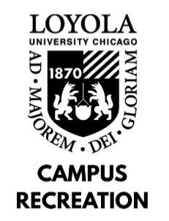

GROUP EXERCISE INSTRUCTOR JOB DESCRIPTION

Departmental Student Employment Philosophy: As a student employee with Campus Recreation, you will play a vital role in providing recreational and social experiences to the university community. In combination with gaining experience in interpersonal communication and conflict resolution, employment with Campus Recreation will provide you with personal and professional development sessions, leadership opportunities, and comprehensive training programs designed to enhance your self-awareness, sense of community on campus, and critical problem-solving skills.

General Position Description: Group Fitness Instructors are primarily responsible for conducting effective group fitness classes, educating patrons on basic fitness knowledge and maintaining a safe and enjoyable workout environment for class participants.

Minimum Skills and Qualifications:
- Must possess a current group exercise or specialty certification from a nationally recognized certifying body (i.e. AFAA, ACE, Mad Dogg Spinning, etc.)
- Must maintain current American Red Cross CPR/AED and First Aid certifications
- Have team oriented ideals, willingness to work hard, and a desire to learn
- Must be a full-time or part-time student at Loyola University Chicago unless permission is granted by supervisor
- Effective communication and organizational skills
Preferred Skills and Qualifications:
- Previous experience teaching preferred

Job Duties:
- Prepare appropriate warm-up, exercises, stretching, and cool down techniques for the specific class format being taught
- Effectively explain and demonstrate proper exercise techniques, as well as offer modifications to accommodate all participants
- Identify different muscle groups and teach appropriate methods to strengthen and stretch specific muscles
- Maintain cleanliness of the group exercise rooms, making sure all equipment is cleaned and neatly put away at the end of each class
- Log class statistics in Class Counts Sheet
Work Location and Environment:
- Must maintain ability to teach high energy classes in 30 minute and 50 minute increments

Learning Outcomes:
- Identify at least one way in which sense of community on campus has developed.
- Identify at least two ways in which communication skills have developed.
- Identify at least two ways in which problem-solving skills have developed.
- Identify at least one way in which self-awareness has developed.
- Identify at least one way in which leadership skills have developed.

